TEAM YELLOW
Project Manager: Toni Katanušić
Front End Lead: Mihovil Medak
Back End Lead: Domagoj Dušić
Database Administrator Lead: Samuel Spence
General Backup Lead: Ejup Elezi
Full Stack Lead: Franko Fišter

System Documentation
Network Activity
20.04.2026.

Contents
Building the Software 3
Building the Front-End 3
Building the Back-End 3
Running the Thor SDK Service 3
System Architecture 4
Technology Justification 4
Frontend Architecture 5
Backend Architecture 5
Controller Layer 5
Service Layer 5
Data Layer 5
System Data Flow 6
Database System 6
Security 6
Deployment 7
Support and Troubleshooting 7

Building the Software
The Network Activity system is a full-stack application composed of three main components: a React frontend, a Spring Boot backend, and a Node.js Thor SDK service for blockchain integration. Each component must be built and executed for the system to function correctly.

Building the Front-End
Software Needed
Node.js and npm are required to install dependencies and run the React application.

Build Instructions
Navigate to the frontend directory, run 'npm install' to install dependencies, and start the development server using 'npm run dev'. The frontend runs on port 5173.

Building the Back-End
Software Needed
Java 21 and Maven are required.

Build Instructions
Run './mvnw spring-boot:run' (or mvnw.cmd on Windows) from the project root. The backend runs on port 8080.

Running the Thor SDK Service
The blockchain integration layer uses a Node.js service. Navigate to 'thor-sdk', run 'npm install', then 'npm run dev'. The service runs on port 4010 and must be active before backend startup.

System Architecture
The system follows a multi-tier architecture consisting of presentation, application, integration, and data layers.
The frontend (React + Vite) handles user interaction and visualization. The backend (Spring Boot) processes requests and enforces business logic. The Node.js Thor SDK service acts as an adapter to the blockchain network. Supabase provides managed PostgreSQL and authentication.
This architecture ensures separation of concerns, scalability, and maintainability.
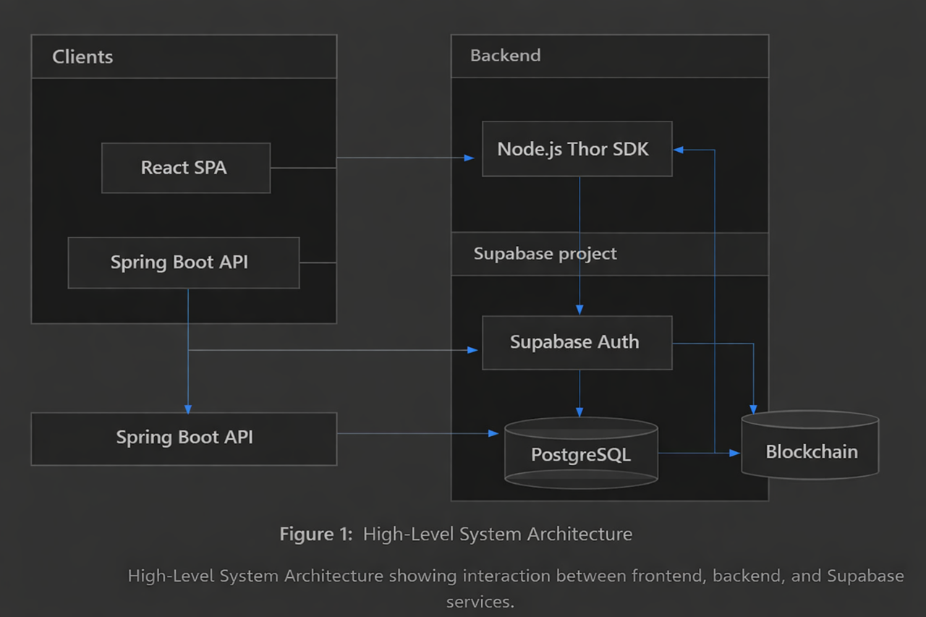

Technology Justification
React was chosen due to its component-based architecture, enabling modular UI development and efficient state management for dynamic dashboards.
Spring Boot provides a robust backend framework with built-in dependency injection, REST support, and strong integration with database technologies, making it ideal for scalable API development.
Supabase was selected to reduce infrastructure overhead by providing a managed PostgreSQL database and authentication system.
The Node.js Thor SDK was used because blockchain SDKs are more mature in JavaScript, allowing easier interaction with blockchain nodes.

Frontend Architecture
The frontend is structured using reusable React components located in the components directory.
Major components include Dashboard, BlockchainExplorer, LabelManagement, RiskMonitoringDashboard, and TransactionFlowVisualization.
HTTP communication is performed using the native fetch API. API logic is centralized in utility modules to ensure maintainability.
The UI supports role-based rendering, ensuring users only see permitted functionality.

Backend Architecture
The backend follows a layered architecture consisting of controller, service, and data layers.

Controller Layer
Controllers expose REST endpoints and handle incoming HTTP requests. They validate inputs and delegate processing to service classes.

Service Layer
The service layer contains core business logic. Key services include:
- FlowService: Handles transaction flow analysis and aggregation.
- RiskService: Detects anomalies and calculates risk scores.
- MetricService and MetricCollector: Manage system metrics and data sampling.
- ClusterService and ClusterWalletService: Manage wallet clustering logic.
- TransactionIngestionService and TransactionSyncService: Handle blockchain data ingestion.
- LabelService: Manages labeling of blockchain entities.
- SearchService: Provides search functionality across datasets.
- UserProfileService: Handles user-related operations.

Data Layer
The data layer uses Spring Data JPA repositories to interact with PostgreSQL. It ensures abstraction over raw SQL and supports efficient querying.

System Data Flow
- User interacts with the frontend.
- Frontend sends HTTP request using fetch API.
- Backend receives request via controller.
- Service layer processes business logic.
- Backend queries database or calls Thor SDK service.
- Thor SDK retrieves blockchain data if needed.
- Backend processes and stores data in PostgreSQL.
- Response is returned to frontend and rendered to user.

Database System
The system uses PostgreSQL via Supabase as the primary data store.
Core tables include metric_samples, addresses, labels, transactions, clusters, and user_profiles.
The schema enforces referential integrity and supports analytical queries.
Additional junction tables such as cluster_wallets manage many-to-many relationships.

Security
Authentication is handled using Supabase Auth.
Users receive a JWT upon login, which is included in API requests.
The backend validates JWTs using a shared secret and enforces authorization through filters.

Deployment
The application consists of three services:
- Frontend (port 5173)
- Backend (port 8080)
- Thor SDK (port 4010)
All services must be running for full functionality.
Environment variables must be configured for Supabase credentials and JWT secrets.

Support and Troubleshooting
Common issues include backend not running, incorrect environment variables, or expired JWT tokens.
Ensure all services are active and properly configured.

